PROJECT REPORT

Project Title: Number Guessing Game GUI Application
Developed By: Arushi Sharma
Registration Number: 25BCE10638

- INTRODUCTION:
This report details the development of a simple Number Guessing Game implemented as a desktop application using Python and the Tkinter graphical user interface (GUI) library. The game challenges the user to guess a randomly selected integer between 1 and 20 within a limited number of attempts (10 attempts). The application provides real-time feedback on each guess, indicating whether the guessed number is too high, too low, or correct. This project serves as an excellent demonstration of fundamental GUI design principles, event handling, and core game logic implementation in Python.

- PROBLEM STATEMENT:
Develop a simple, user-friendly, and interactive GUI-based number guessing game using Tkinter. The application must:
1. Allow a user to input and retain their name for a personalized welcome
2. Randomly select a target number within the fixed range of 1 to 20
3. Allow the user a fixed number of attempts (10) to guess the number
4. Provide immediate feedback after each guess (too high, too low, or correct)
5. Validate all user inputs to ensure they are within the required numeric range
6. Clearly indicate when the user wins or loses, displaying the correct number upon losing
7. Offer a simple mechanism to reset and restart the game ("Play Again")

- FUNCTIONAL REQUIREMENTS:
1. Name Input: The user must be able to input their name, which is then used in the welcome message.
2. Random Number Generation: The system must generate a random integer between 1 and 20 at the start of each new game.
3. Guess Input and Submission: The user must be able to enter a number (1-20) into a dedicated field and submit it as a guess via a button click or the Enter key.
4. Input Validation: The system must validate that the input is a valid integer between 1 and 20; otherwise, an error message must be displayed.
5. Guess Feedback: The system must provide instant feedback: "too large," "too small," or "CORRECT GUESS."
6. Attempts Tracking: The system must track and display the current number of attempts used out of the maximum of 10.
7. Win/Loss Condition: The game must conclude when the correct number is guessed (win) or when 10 attempts are exceeded (loss), at which point the guess inputs are disabled.
8. Restart Mechanism: A "Play Again" button must appear upon game termination to reset all variables and the GUI to the initial state.

- NON-FUNCTIONAL REQUIREMENTS:
1. Usability:
Requirement-1: The user interface must provide clear, concise instructions and feedback messages in plain language, indicating whether the guess was "too large," "too small," or "CORRECT."
Requirement-2: The GUI must utilize an effective visual hierarchy by disabling irrelevant input fields and buttons (e.g., the name entry field once the game starts) and enabling only the components needed for the current game state, reducing user confusion.
2. Performance:
Requirement-1: The application must respond to user input (button clicks or pressing the Enter key) with immediate feedback (less than 100 milliseconds lag) to ensure a smooth, interactive experience.
Requirement-2: The game initialization process (random number generation, variable reset) upon clicking "Start Game" or "Play Again" must complete instantaneously (e.g., within 50 milliseconds).
3. Reliability:
Requirement-1: The game logic must accurately track and enforce the maximum attempt limit of 10, ensuring the game always terminates correctly on a win or a loss condition.
Requirement-2: The application must consistently handle valid integer inputs between 1 and 20 without generating runtime errors or exceptions.
4. Error Handling Strategy:
Requirement-1: The application must validate all inputs against the expected numeric type and range (1-20). If the input is invalid (e.g., non-numeric or out-of-range), an error message must be displayed to the user via the feedback_label or a messagebox, and the attempt count must not be incremented.
Requirement-2: The game must display an error message if the user attempts to start the game without first entering a name.

- SYSTEM ARCHITECTURE:
The Number Guessing Game is built using a Single-Tier Desktop Architecture. All components—the graphical interface, the core game logic, and data handling—are contained within a single Python script and run entirely on the user's local machine.
1. Presentation Layer (client): Implemented using the Tkinter library, managing all visual elements and handling user events.
2. Logic Layer: Implemented in Python, containing the functions that manage the game rules, state transitions, and random number generation.
3. Data Layer: No persistent data storage (like a database or file) is required. All game state data (target number, attempts count, player name) is held in global variables in the process memory for the duration of the application run.

- DESIGN DIAGRAMS:
1. Use Case Diagram:
This diagram illustrates the primary ways the Player interacts with the System.
(i) Primary Actor: player
(ii) Use Cases: Enter Name, Start Game, Submit Guess, Receive Feedback, Win Game, Lose Game, Reset/Play Again.
2. Workflow Diagram:
This diagram outlines the flow of events during a single session of the Number Guessing Game.
(i) Start: Game initialized, waiting for name input.
(ii) Input: Player Enters Name Then Clicks "Start Game".
(iii) Process: System Generates Target Number (1-20).
(iv) Loop: Guess & Check:
Player Submits Guess.
Validation Check:
Is input valid (1-20)?
No: Display Input Error and Continue Loop.
Win Check: Is Guess = Target?
Yes: Win Game then End
Loss Check: Is Attempts >= Max Attempts (10)?
Yes: Lose Game then End.
Feedback: Provide "Too High" or "Too Low" feedback to Continue Loop.
(v)End: Game Over, "Play Again" button enabled
3. Sequence Diagram:
This diagram details the sequence of interactions when the user attempts a guess.
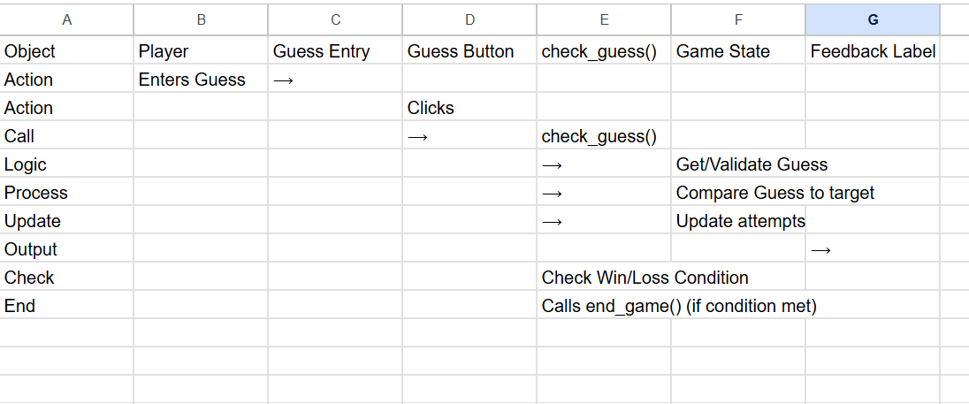

4. Class/ Component Diagram:
The application is structured around its global state variables and the functions that manipulate them and the GUI widgets.
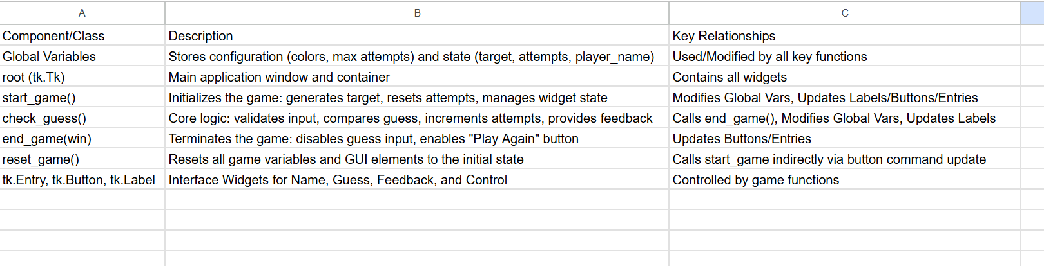

- DESIGN DECISIONS AND RATIONALE:
1. Tkinter Selection:
Tkinter was chosen as the GUI library because it is standard, lightweight, and requires no external dependencies (import tkinter as tk). This simplifies distribution and maintainability.
2. Procedural Structure:
For a simple, single-window application, a procedural, event-driven structure (defining functions like start_game and check_guess and binding them to button events) is the most efficient and readable design.
3. Game State Management:
Global variables were intentionally used for core state variables (target, attempts, player_name). This avoids complex object-oriented patterns which would be overkill for this project's scope.
4. Usability Enhancements:
(i) Custom color variables were used for a distinctive, softer aesthetic (bg_color, button_color) over the default system colors.
(ii) The Return Key Binding (root.bind('<Return>', on_return_key)) was implemented to allow users to press Enter to submit their guess, improving workflow (PER1).
5. Robust Input Handling:
The check_guess function includes explicit isdigit() and range checks (1-20) to ensure the application resists crashing from non-numeric or invalid inputs (ERR1).

- IMPLEMENTATION DETAILS:
The implementation is centred around the management of state variables and updating widget configurations:
1. Variable Configuration:
All colors and limits (max_attempts=10) are set at the script's start.
2. start_game() Function:
This function is the primary setup routine. It retrieves the player name using name_entry.get().strip(), validates the presence of the name (ERR2), and then uses random.randint(1, 20) to set the target. It then performs critical state changes:
guess_button.config(state=tk.NORMAL)
name_entry.config(state=tk.DISABLED)
3. check_guess Function:
This function handles the main game logic.
(i) It retrieves input using guess_entry.get().strip() and clears the entry immediately
(ii) It uses if not guess_str.isdigit() and range checks to implement input validation (ERR1).
(iii) It provides conditional feedback based on the comparison of guess and target
(iv) It calls end_game(win) when guess == target or when attempts >= max_attempts (REL1).
4. GUI Layout:
The grid geometry manager is employed for simple vertical stacking and centring of the main components (title_label, name_frame, start_button, etc.).

- SCREENSHOTS/ RESULTS:
1. The game is waiting for name input. The "Start Game" button is active. The Guess input area is disabled.
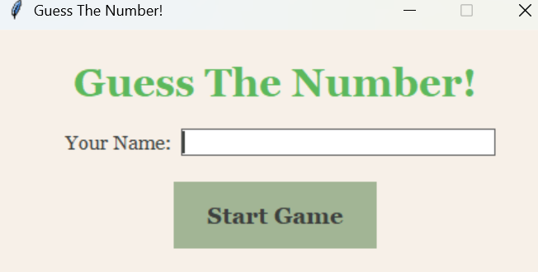

2. The game is in progress (attempts 4/10). The player’s name is displayed. A feedback message ("Your number was too large. Guess again.") is shown. The guess input is active.
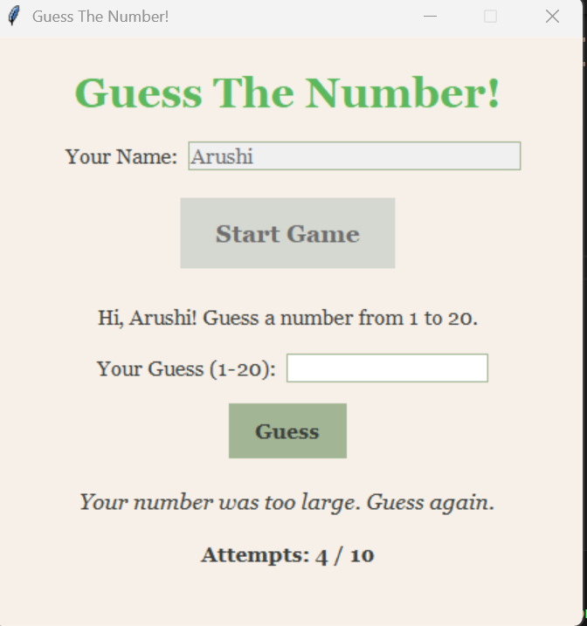
3. The game has ended. A celebratory/loss message is displayed (e.g., "🎉 CORRECT GUESS! YOU WON!!"). The input fields are disabled, and the "Play Again" button is active.
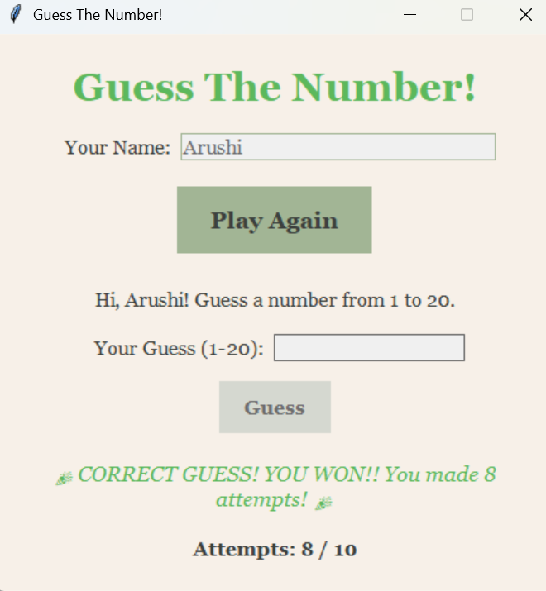

- TESTING APPROACH:
A Black-Box Testing methodology was used to verify the application's compliance with functional and non-functional requirements, focusing on user interactions and game logic outcomes.
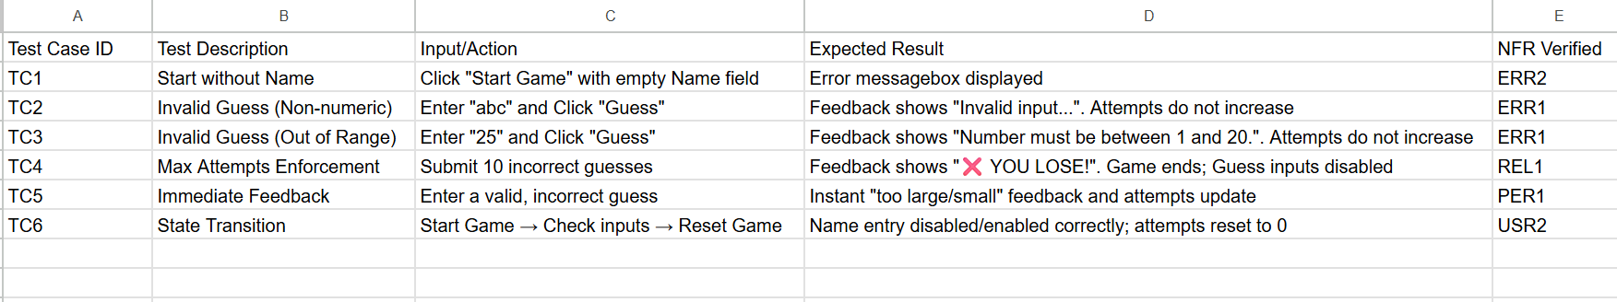

- CHALLENGES FACED:
1. Input Clearing and Focus:
Ensuring that the guess_entry was cleared (guess_entry.delete(0, tk.END)) immediately after submission and that the input focus was correctly set (using focus_set()) to the relevant entry field for the current state (name_entry or guess_entry) was crucial for a smooth user experience
2. State Control Complexity:
Managing the enabling and disabling of multiple widgets across four distinct functions (start_game, check_guess, end_game, reset_game) required careful testing to prevent the user from clicking the wrong button at the wrong time (e.g., preventing guessing before starting the game).
3. Error Handling Placement:
The logic to validate input had to be placed before the attempts += 1 statement in check_guess to ensure invalid guesses do not unfairly penalize the player (REL1, ERR1).

- LEARNINGS AND KEY TAKEAWAYS:
1. GUI Programming Paradigm:
Gained practical understanding of event-driven programming, where application flow is determined by user actions (events) rather than a sequential program structure.
2. Separation of Concerns:
Learned how to effectively separate the Presentation (Tkinter widgets) from the Logic (game rules in functions) by using callback mechanisms and state variables.
3. Robustness is Key:
The most valuable lesson was the necessity of designing for invalid inputs. Implementing specific validation routines for type and range checks significantly increased the application's reliability and user-friendliness (ERR1).
4. Importance of NFRs:
Understanding how NFRs, such as Usability (clear feedback) and Performance (instantaneous response), transform a merely functional script into a quality user application.

- FUTURE ENHANCEMENTS:
1. Difficulty Scaling:
Allow the user to select difficulty, dynamically changing the guess range (e.g., 1-50, 1-100) and adjusting max_attempts.
2. High Score Tracking:
Integrate a simple data persistence mechanism (e.g., JSON file or pickle) to record and display the player's best scores (fewest attempts).
3. Visual Enhancements:
Implement more dynamic feedback, such as changing the border color of the feedback_label to red/green/yellow based on the closeness of the guess.
4. Modularity:
Refactor the code into a dedicated Game class to encapsulate all state variables and methods, adhering to an Object-Oriented Programming (OOP) design for better scalability and maintainability.

- REFERENCES:
1. Tkinter Official Documentation
2. https://www.geeksforgeeks.org/python/python-gui-tkinter/
3. https://www.educative.io/answers/what-are-the-basic-functions-of-tkinter-in-python

